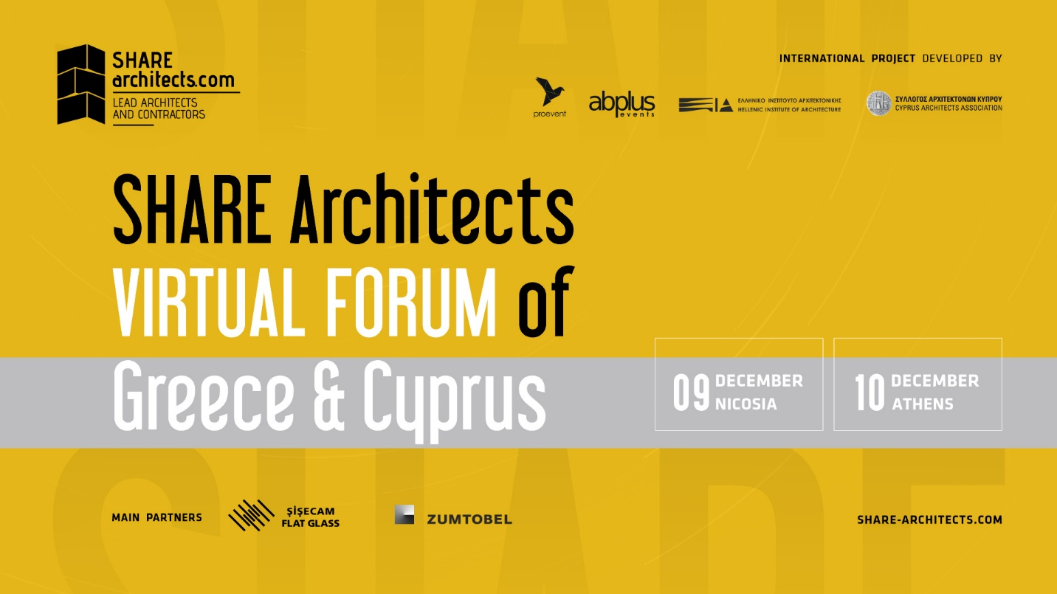

Set yourself up for success at SHARE Architects Virtual Forum of Greece and Cyprus

SHARE Architects is pleased to announce the International Architecture and Engineering Forum organized together with the Hellenic Institute of Architecture, the Cyprus Architects Association and The Cyprus Scientific and Technical Chamber on 9th and 10th of December.
Architecture students are invited at SHARE Forum to engage in two days of FREE live content, lectures, panel discussions, and networking.
SHARE Architects virtual forum of Greece and Cyprus will focus on challenges and new opportunities of contemporary architecture, with a complex program including projects and speakers with outstanding results in architecture.
Headline speakers
09th of December, 14.00- 19.00, virtually on Whova, online dedicated platform
Christos CHRISTODOULOU- President of the Cyprus Architects Association
Eraclis PAPACHRISTOU - Founder of Eraclis Papachristou Architects
Michael COSMAS - Director, Michael Cosmas Architecture LLC
Gregoris G. PATSALOSAVVIS - Founder Gr. G. Patsalosavvis Architecture + Design - Cyprus
Jan GEHL - Founder Gehl architects – DENMARK; Author of ”Cities for People”
John MCELGUNN - Partner Rogers Stirk Harbour + Partners – UK;
Peter MURRAY - Chairman London Festival of Architecture, Curator-in-Chief New London Architecture and the London Society – UK
Farshad MEHDIZADEH - Co-Founder FMZD - IRAN;
Ervin TACI - CEO DEA Studio – ALBANIA
10th of December, 14.00 – 19.00, virtually on Whova, online dedicated platform
Elias CONSTANTOPOULOS - President of the Hellenic Institute of Architecture
Mara PAPAVASILEIOU - Co-Founder Micromega Architecture & Strategies - GREECE
Leonidas PAPALAMPROPOULOS - Founder leonidas papalampropoulos architecture bureau - GREECE
Tsampikos PETRAS - Founder PETRĀS architecture - GREECE
Herman HERTZBERGER - Founder AHH, one of the leading Dutch theorists and architects of the modern age. Hertzberger can be considered, along with Aldo van Eyck, as the influence behind the Dutch structuralist movement of the 1960s and 1970s.
Frédérique MONJANEL - CEO Ateliers Jean Nouvel, President of the board of directors of the École Nationale Supérieure d’Architecture de Paris-Malaquais
Alireza TAGHABONI - Founder NextOffice - IRAN;
Dean LAH - Owner - Principal Enota - SLOVENIA;
Check out the agenda and the speakers' panel:
https://bit.ly/3pWARYh
WHOVA - an online dedicated platform
The entire SHARE event can be watched live on the dedicated online platform - Whova. Accessing the platform can be done both on the mobile phone and on the desktop and it is only allowed to registered participants and speakers. Even in times of the COVID-19 pandemic, it offers the ideal platform to maintain contacts, share information, give business a boost, and discuss the latest issues.

Register for FREE to SHARE Architects virtual forum of Greece and Cyprus 2020
https://whova.com/portal/registration/share_202009
You will be able to login to a dedicated online platform to benefit from:
- Live keynote speeches, panel debates;
- Opportunity for live Q&A with speakers;
- Access to recordings, videos and slide decks after the event;
- Direct messaging with other attendees and business card exchange;

About SHARE architects
The SHARE Forum has created in the past 23 years an essential networking platform for professionals in the AEC (architecture, engineering, and construction) industries from Central and Eastern Europe. The forums create an efficient platform for getting in contact with and understanding the diversity of the contemporary architectural phenomenon. Presently, the SHARE events are held in 15 countries from Central and Eastern Europe and the SHARE Community has over 50.000 members worldwide.
For customer service, bookings, and sponsorship opportunities please contact us at share@abplusevents.com

