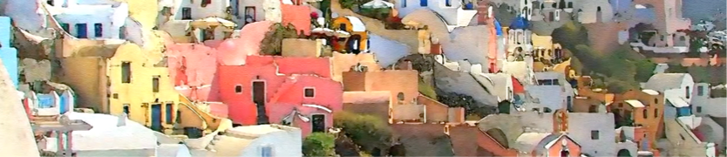
International student workshop
place and locality vs. modernism: examples of emerging new paradigms in Architectural Design
Hosted by School of Architecture NTUA,
Technological Cultural Park of Lavrion, Athens
Sunday 16 July – Thursday 20 July 2017

Participating Institutions
- School of Architecture, University of Cyprus, Nicosia, Cyprus
- School of Architecture, Aristotle University of Thessaloniki, Greece
- School of Architecture, National Technical University of Athens, Greece
- School of Architecture University of Sapienza, Rome, Italy
- School of Architecture, Institute Manuel Teixeira Gomez, Portimão, Portugal
- School of Architecture, University of Beira Interior, Covilhã, Portugal
- School of Architecture, Vallès, ETSAV, Barcelona, Spain

How the characteristics of a Mediterranean place can inspire contemporary architectural creation in both architectural design level, and in design of public space? Our intensive workshop will use as vehicle architectural design themes focusing on innovative and experimental approaches to local cultural heritage and social problems and will inspect how new technologies and environmental issues can serve creatively the above themes.
ARCHI-MED-ES project will be able to reimburse students’ travel expenses to the amount of 275 Euros and their accommodation expenses for 5 students of the 4th or 5th year of studies from each participating Institution.
Students from School of Architecture, Aristotle University will submit their documents (degree transcript, English language certificate, cv) by Monday 15 May 2017 to the Secretary of Department of Urban and Regional Planning, Mrs D. Konstantinidou, 2nd floor, main administration building of Faculty of Technology (tel.2310 995470) or by e-mail at dimkon@arch.auth.gr , titled: For ARCHIMEDES project participation.

